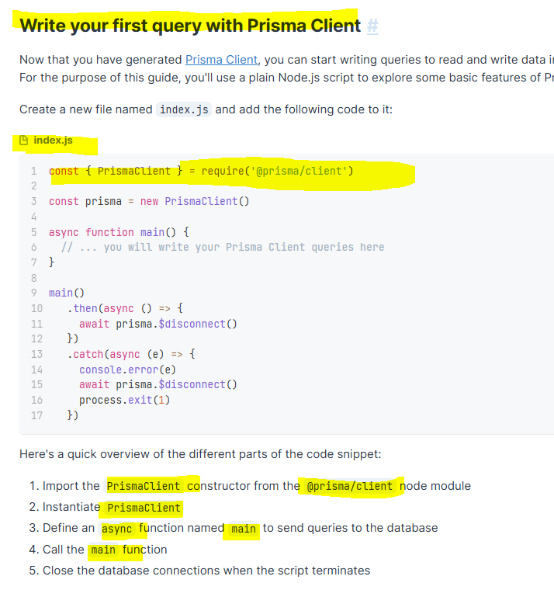

index.js

const { PrismaClient } = require('@prisma/client')  
const prisma = new PrismaClient()  
  
async function main() {  
 // ... you will write your Prisma Client queries here  
}  
  
main()  
 .then(async () => {  
 await prisma.$disconnect()  
 })  
 .catch(async (e) => {  
 console.error(e)  
 await prisma.$disconnect()  
 process.exit(1)  
 })

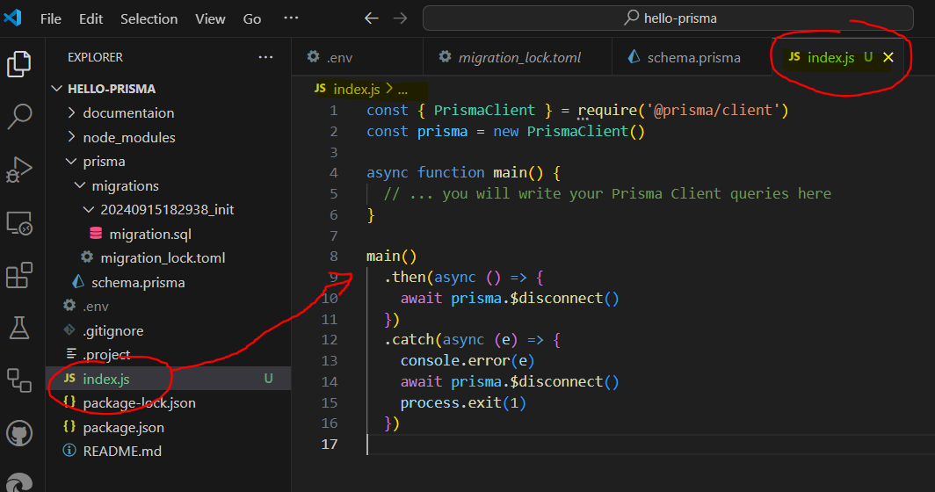

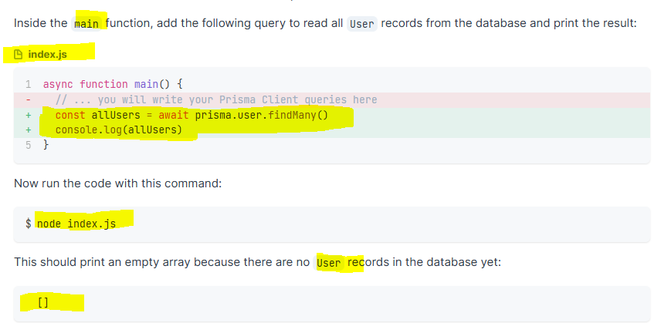

index.js

async function main() {  
 *// ... you will write your Prisma Client queries here*  
 const allUsers = await prisma.user.findMany()  
 console.log(allUsers)  
}

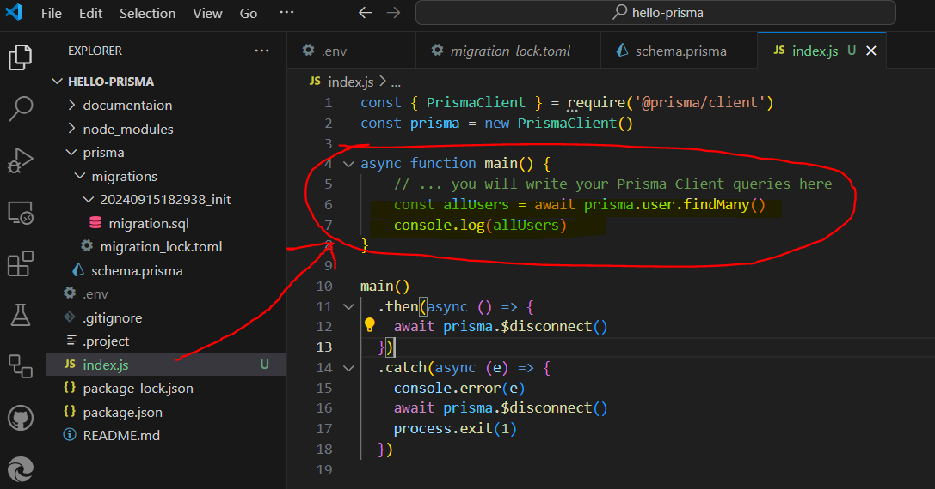

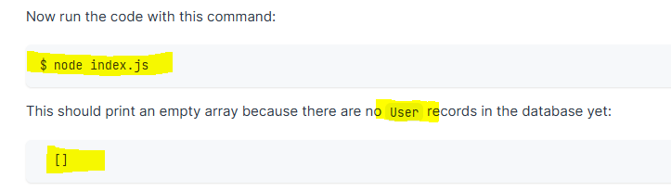

C:\Users\Family\git\hello-prisma> node index.js

